Adam Gincel

History Through Games

HAR495

Adam Gincel

Professor O’Brien

HAR495

28 November 2016

History Through Games

*The Oregon Trail* was first developed as a classroom educational tool in 1971, and was one of the first games that aimed to teach players about life during a real period of time. It was used by Don Rawitsch to teach his 8th grade history students about life as a pioneer in the 1800s. The game tasks the player with selecting a small group of people to make the dangerous trek across the continental United States in the year 1848. It found great success locally and was later bundled with school computer programs and went on to become one of the most popular educational gaming tools ever made.[1] As gaming has advanced as a medium we have seen games that tackle any number of different social issues, gameplay styles, and environments. Throughout the past decade in particular there has been an increase in the number of games that use historical locations and time periods as the backdrops of their stories. The *Call of Duty* series, earlier on, used real war conflicts as means to drive their plot and gameplay forward. The *Assassin’s Creed* series sees players living through previous lives in historical cities and times like Venice during the Renaissance or colonial America during the Revolutionary War. More interestingly than these timepieces, or games that use history as a backdrop to their own stories, are historical dramas - games that use their plot as a means to let players learn or experience real history. Larger studios have not been responsible for this trend. Instead, independent studios and developers like iNK Stories, Peter Brinson and Kurosh Valanejad, and Studio Oleomingus, among others, have lead the charge, crafting games and experiences that aim to teach, inform, and expose players to historical events big and small.

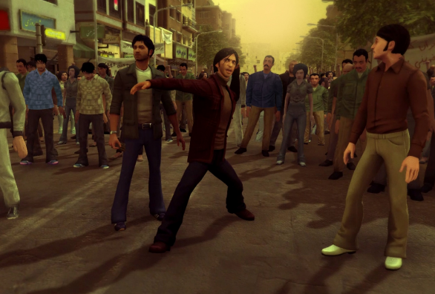*1979 Revolution: Black Friday*, from iNK Studios, was released in April 2016. The game is a narrative experience with choices that impact the story throughout. It is set in Iran during the 1979 Revolution, where the Pahlavi dynasty was overthrown, and replaced with a theocratic system of government under a supreme leader, Ruhollah Khomeini.[2] Reza, the game’s protagonist, was a journalist who was thrust into the conflict by his friend Babak and his brother Hossein. The player experiences Reza’s struggles and the decisions he is forced to make, and through his eyes they learn firsthand the conflict and strife of late 1970s Iran during an incredibly tumultuous period. The game is noteworthy in that it is able to impart historical context and understanding in only a few hours of playtime, in a way that leaves a lasting memory with its players. One who has never been exposed to any information about this period of Iran’s history may, upon its completion, walk away from this game with greater understanding and interest in it than they had before. Interestingly, the game worked so hard at providing an objective view on the status of Iran’s government that it was actually banned in the country for having “hostile intentions.[3]” This is a testament to its strong message and devotion to informing its players. Between the game’s storytelling, characters, and abundance of true historical documents present throughout the experience, it is able to teach history in a novel, memorable, and impressive fashion.

Violence breaks out in a mob in *1979 Revolution: Black Friday*, by iNK Studios.

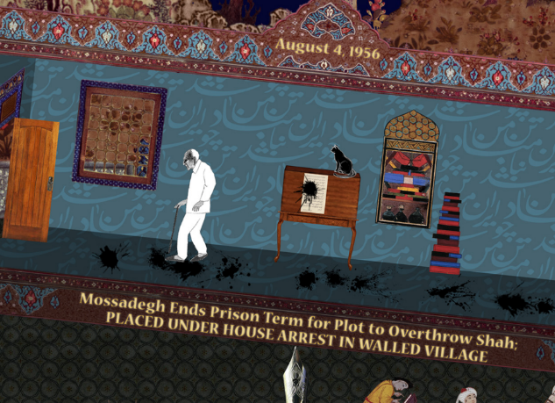Iran’s storied history could not possibly fit into a single game, and there are other games that have focused on its noteworthy moments and people. *The Cat and the Coup*, released in 2011 by Peter Brinson and Kurosh Valanejad focuses on the life and actions of Dr. Mossadegh, the former Prime Minister of Iran, focusing on events from 1953 and onwards. Unlike *1979,* which brought the player through a very direct, hands-on historical experience,the game features puzzles that are loosely related to historical events, while presenting imagery and narrative through an abstract world, working backwards from Mossadegh’s death. After the last puzzle, the game brings the player through a scripted sequence teaching them about Dr. Mossadegh’s decision to nationalize Iran’s oil. This decision instilled a confidence in Iran’s populace, but upset many foreign actors – particularly the United States. His decision had several geopolitical consequences, which ultimately culminated in his detainment, house arrest, and decline from power.[4] *The Cat and the Coup* presents this information from the perspective of the Iranian people, which helps players receive historical context they might not otherwise see in American news, art, or politics. The game uses its unique presentation to introduce players to a historical figure, and showed how that figure’s actions affected themselves, their nation, and their populace.

*The Cat and the Coup*, by Peter Brinson and Kurosh Valanejad, presents abstract puzzles while exposing the player to historical events.

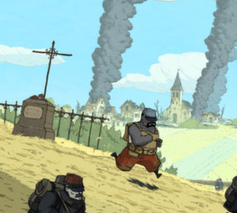Geopolitics affects many people, powerful or otherwise, in unexpected ways – through the first half of the 20th century, World Wars 1 and 2 showed the populations of the world just how much political tension could affect their everyday lives. *Valiant Hearts: The Great War*, released in 2014 by Ubisoft Montpelier, explores how the first World War affected people on an individual level, while concurrently teaching the player about the sequences of events leading up to and throughout the war. With the backing of Ubisoft the game is considered AAA, but the game was made according to the artistic vision of a small team, in this case inspired by letters sent by soldiers during and after WWI. The game is a 2D puzzle and exploration game, and follows the stories of four people as they try to handle the upheaval of their lives due to war. Unlike *1979* and *The Cat and the Coup*, which provided historical exposure to periods of time the players may have little experience with, *Valiant Hearts* aims to provide different angles of understanding to a period many players may already be acquainted with. The game focuses on the humanity of the soldiers on many fronts, straying away from the dehumanizing nature of war and instead showing players that all sides lose through its horrors. Like *1979*, throughout the game the player picks up various objects and witnesses events that unlock real historical letters, documents, and artifacts that are optional to view. These provide additional insight and context to the events of the game, and help lend to its educational nature.

*Valiant Hearts: The Great War* published by Ubisoft focuses on the human struggles of four people amidst a horrible global conflict.

Not all games about history and places of historical significance aim to teach, however. Many games could be classified as timepieces – these games have their own plots, characters, and worlds, but are dressed to appear as if they are taking place in a specific time period. *Assassin’s Creed III*, released in 2012 by Ubisoft Montreal, is an example of such a game. The entire *Assassin’s Creed* series is about an alternate history where all important events throughout time have been as part of an ongoing conflict between two groups: The Templars and the Assassins. This is a great example of a timepiece – the story of *Assassin’s Creed* stretches itself through most of modern history, and is thus able to plant itself into any noteworthy historical place or time. Throughout its lifetime, the series has visited the Holy Land, Venice, Rome, New England, Constantinople, Paris, and London. In each of these, figures of historical significance are used by the games as means to further their own plot and mechanics, while providing brief, fleeting glimpses into their significance as real world figures. One particularly egregious example is George Washington in *Assassin’s Creed III*, whose life is saved by the game’s protagonist from an attack from Charles Lee, who the game establishes is a Templar. The game 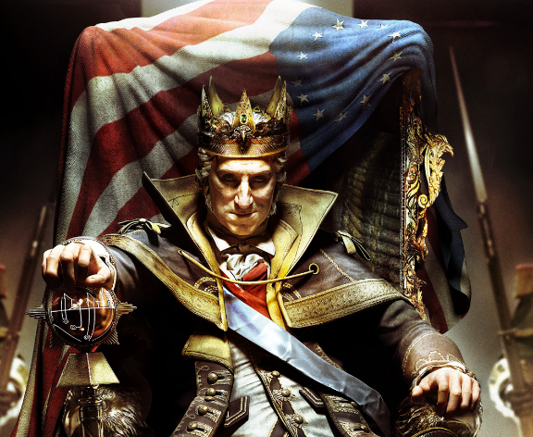also features an alternate timeline DLC story in which George Washington becomes corrupted by an artifact known as the Apple of Eden. Under its influence, he becomes mad with power and instates a dictatorial monarchy. The player is then tasked with overthrowing the hypothetical King Washington while he attempts to massacre the populace. Examples like these can be found throughout the series – even the portions of the games that are more accurate to history still use it as a backdrop to their own plots. To quote *Assassin’s Creed: Revelations* director Alexandre Amancio: “…that’s the whole point. History is our playground.[5]” This attitude epitomizes the issue with timepieces: by using history as a playground rather than presenting it with more tact, studios run the risk of misinforming players about periods of time, and robbing them of lessons the past may be able to teach them. While they can boast about taking place during historical events, and could even say they teach their players about history, much of the nuance is lost as the history seen in the game is far from the main focus, and is instead merely set dressing for a different experience altogether.

*Assassins’s Creed III*, published by Ubisoft, had a DLC storyline entitled *The Tyranny of King Washington*, wherein George Washington became a violent dictator the player had to overthrow.

In the same vein, *Call of Duty: World at War,* released in 2008 and developed by Treyarch, uses history as a backdrop for its gameplay and story. It tells the story of a marine private who survives the execution of his squad by the Japanese and joins in on multiple war fronts, committing various atrocities throughout. The game routinely tasks the player with killing numerous enemy combatants, in aggressive war scenarios that play more towards one’s propensity towards behaving like an action movie hero than like real military tactics. Any historical context is immediately overshadowed by a heavy emphasis on objectives and combat, a lot of which lends to the ever popular competitive multiplayer aspect of the game. This is in stark contrast to the nuanced and personable storytelling seen in *Valiant Hearts*. The difference between these two games could be described, in short, as the difference between a humanizing story and a dehumanizing story. *Valiant Hearts* aims to teach that people on all sides of the war have real emotions and motivations beyond the army they are a part of, and *Call of Duty: World at War* conditions the player into viewing the opposing army as inhuman targets, just as real war propaganda tends to.[6] This difference epitomizes the contrast between timepieces and historical dramas, the latter of which put real work into respecting and communicating the periods of time they convey.

Games are a powerful, immersive entertainment medium. They immerse players in an environment for varying lengths of time, during which they have the ability to impart experiences, or even memories, of any given subject material. Games that seek to entertain may focus on gameplay mechanics, with environments that focus on challenging a gamer’s technical skill or ability, and reward them for learning and performing well. Alternatively, games may seek to communicate more nuanced subjects, informing and educating players on material like history or social issues. These games sit in strong contrast to games that seek to further their own agendas while using history or social issues as backdrops. *1979, The Cat and the Coup,* and *Valiant Hearts* teach history in a very factual manner, backing up events throughout their experiences with historical references and documents. Conversely, *Assassin’s Creed* and *Call of Duty* use real history as a blueprint, which then gets covered by imposing alternate history storylines or heavy combat focus. The primary difference between these is the difference between a historical drama and a timepiece; historical dramas focus on real events and happenings, and expose their viewers to them, while timepieces have their own distinct stories which come before any historical context. Throughout gaming’s history historical dramas have often been lauded for their ability to teach and inform their players about subjects that are otherwise nuanced and challenging to explain. The trend started by *The Oregon Trail* the 1970s lives on today in games that are created to spread stories and their messages to players around the globe. These games, unlike their timepiece counterparts, are able to leave lasting, memorable experiences with their players, and may ultimately help contribute to a more informed society.

Works Cited

Amuzegar, Jahangir. *Dynamics of the Iranian Revolution*. p. 253. 1991. *Google books.* Print.

Cragg, Oliver. *PC game 1979 Revolution: Black Friday banned in Iran, accused of 'hostile intentions.'* IBTimes. N.p. 9 June 2016. Web.

James, Michael. *Demonizing the Enemy, a Hallmark of War.* ABCNews. N.p. 29 Jan. 2003. Web.

Pereira, Chris. *Expect a Larger Gap Between Future Assassin's Creed Releases.* 1up. N.p., 3 Oct. 2011. Web.

Rosenberg, Eli. *Sally Has Diphtheria: Is Oregon Trail the Greatest Video Game of All Time?"*  The Wire. N.p., 21 Jan. 2011. Web.

Yergin, Daniel. *The Prize: The Epic Quest for Oil, Money and Power.* N.p. 2008. New York: Free Press. Print.

1. Rosenberg, Eli
2. Amuzegar, Jahangir
3. Cragg, Oliver
4. Yergin, Daniel
5. Pereira, Chris
6. James, Michael